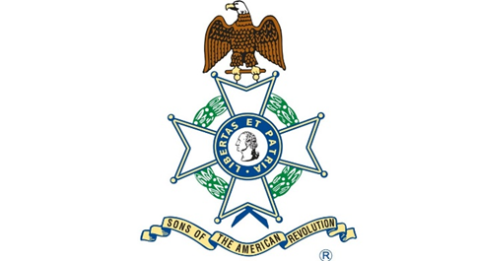

Maria Robania de Betancourt

Born about 1703

Died January 26, 1779

Spain (Texas)

Maria Robania de Betancourt was born about 1703 in Lanzarote, Canary Islands, Spain. She was the daughter of Manuel de Betancourt and Paula Umpienes. She married Juan Rodriguez Granado while living in the Canary Islands, Spain. She and her family traveled from the Canary Islands to Veracruz, New Spain. Her first husband, Juan Rodriguez Granado, had died in Veracruz of tropical fever. Twenty-seven years old, with six children, Maria was the head of the Fourteenth Family to arrive in La Villa de San Fernando later to be known as San Antonio, Texas on March 9, 1731 at 11am. Her description indicates that she had a “good figure, slender long face, fair complexion, black hair and eyebrows, thin nose.” Maria was granted the Granado homestead on the southeast corner of Main Plaza and Commerce Street.

Soon after her arrival, Maria married Martin Lorenzo de Armas who was one of the unmarried men that came as well from the Canary Islands. Maria and Martin had 4 children. From her Granado Ranch, San Antonio del Cibolo, Maria sent Longhorn cattle to feed the troops of General Bernardo de Galvez in the Spanish Louisiana Territory. Her extravagantly furnished home in San Antonio became the social center of San Fernando de Bexar. Maria died on January 26, 1779 and is buried at the San Fernando cemetery.

